Program Review Report
October 2008
Distance Education

Part I: Introduction

What process was used in doing the program review?

The Distance Education Program Review Team comprised Deborah Nolan and Alicia Crumpler.
Nolan and Crumpler attended Dr. Johnson’s workshop and met three times in the spring 2008 semester. In order to compile information for the report, Nolan reviewed various historical documents including minutes from past COS distance learning committee meetings, the most recent COS WASC self-study report, and the most recent COS Master Plan. DECOS reviewed the draft prior to submission.
Program Review documentation includes the program review report, various reports from COS Planning and Research, and Student and Faculty Satisfaction Surveys.

Mission

Distance education at COS is not a program, per se, but rather comprises efforts on the part of the institution to provide technology-mediated access for students to COS educational programs in keeping with the COS Mission:

College of the Sequoias is a comprehensive community college focused on student learning that leads to productive work, lifelong learning and community involvement.
College of the Sequoias affirms that our mission is to help our diverse student population achieve their transfer and /or occupational objectives and to advance the economic growth and global competitiveness of business and industry within our region.
College of the Sequoias is committed to supporting students' mastery of basic skills and to providing programs and services that foster student success.
Adopted by the Board of Trustees on May 14, 2007

The mission of Distance Education at College of the Sequoias (COS) is to extend educational opportunities to a diverse population who prefer or have need of alternative methods of delivery. These approaches to instruction outside the traditional classroom setting provide greater opportunities for students to obtain the education they need to achieve their goals, while continuing with demanding personal and employment schedules.

(Approved by DECOS, April 2008)

Definitions

Title 5 Definition of DE. § 55200
Distance education means instruction in which the instructor and student are separated by distance and interact through the assistance of communication technology. All distance education is subject to the general requirements of this chapter as well as the specific requirements of this article. In addition, instruction provided as distance education is subject to the requirements that may be imposed by the Americans with Disabilities Act (42 U.S.C. s 12100 et seq.) and section 508 of the Rehabilitation Act of 1973, as amended (29 U.S.C. s 794d).

Ed Code Section 51865

‘Distance learning’ means instruction in which the pupil and instructor are in different locations and interact through the use of computer and communications technology. Distance learning may include video or audio instruction in which the primary mode of communication between pupil and instructor is instructional television, video, telecourses, or any other instruction that relies on computer or communications technology.

WASC Accreditation definition of DE

Distance learning is defined, for the purposes of accreditation review, as a formal interaction designed for learning in which the interaction principally occurs when the student is separated by location from the instructor, resources used to support learning, or other students. Distance learning may employ correspondence study, audio, video, or computer technologies. Educational interactions delivered through these means may occur on campus as well as off campus. These interactions may be synchronous or asynchronous.

Distance Education at COS: A Timeline

1995-1996
A Distance Learning Task Force was formed.

1996-1997
The Distance Learning Committee was formed, and the distance education program was instituted. COS offered its first online classes: English 1 and English 2.
Curriculum Committee Distance Learning Addendum was approved

1997-1998
Fall
No DE classes
Spring
Two Online Courses: ENGL 001; ENGL 002
One Telecourse: CHLD 039

1998-1999

Fall
Three Online Courses: ENGL 001; ENGL 002; MATH 021
Two Telecourses: CHLD 039; NUTR 018
Spring
Four Online Courses: ENGL 001; ENGL 002; ENGL 004; MATH 021
Two Telecourses: CHLD 039; NUTR 018
One Interactive TV: HW 001

1999-2000
Fall
Four Online Courses: ENGL 001; ENGL 002; ENGL 004; MATH 021
Two Telecourses: CHLD 039; NUTR 018
Spring
Three Online Courses: ENGL 001; ENGL 002; ENGL 004
Four Telecourses: CHLD 039; NUTR 018; LIBR 101; MATH 021

2000-2001
Fall
Five Online Courses*: ENGL 001; ENGL 002; ENGL 004
Four Telecourses: CHLD 039; NUTR 018; LIBR 101; MATH 021
Spring
Five Online Courses: ENGL 001; ENGL 002; ENGL 004
Four Telecourses: CHLD 039; NUTR 018; LIBR 101; MATH 021
Report to the Board

2001-2002
Fall
10 Online Courses: BUS 270; BUS 271; COMP 5; COMP 140; ENGL 1; ENGL 2; ENGL 4
Eight Telecourses: CHLD 039; CHLD 160; NUTR 018: MATH 021; MATH 045; LIBR 101
Spring
16 Online Courses: BUS 270; BUS 271; COMP 5; COMP 140; ENGL 1; ENGL 2; ENGL 4; GOVT 005
Seven Telecourses: CHLD 039; NUTR 018: MATH 021; LIBR 101

2002-2003
Fall
468 students
119 web-enhanced courses
13 online sections
4 televised courses
Distance Education Committee was formed (DECOS)
Accreditation Annual Report
Spring
462 students
15 Online Courses: BUS 270; BUS 271; COMP 5; ENGL 1; ENGL 2;
ENGL 4; GOVT 005; MATH 200; MATH 230
Five Telecourses: CHLD 39; NUTR 018: MATH 021; LIBR 101

2003-2004
Fall
12 Online Courses: BUS 270; COMP 005; ENGL 001; ENGL 002; ENGL
004; MATH 200; MATH 230
Five Telecourses: CHILD 039; NUTR 018; MATH 021; LIBR 101;
Spring
11 Online Courses: BUS 270; BuS 271; COMP 005; ENGL 001; ENGL
002; MATH 200; MATH 230; PSY 039.
Four Telecourses: CHILD 039; NUTR 018; LIBR 101; MATH 021

2004-2005
Fall
14 Online Courses: BUS 270; BUS 271; COMP 005; ENGL 001; ENGL
002; ENGL 004; MATH 200; MATH 230
Six Telecourses: CHLD 39; NUTR 018; LIBR 101; MATH 021; PSY 39
Spring
13 Online Courses: BUS 270; BUS 271; COMP 005; ENGL 001; ENGL
002; ENGL 004; MATH 200; MATH 230
Five Telecourses: CHLD 39; NUTR 018; LIBR 101; MATH 021; PSY 39

2005-2006
Fall
13 Online Courses: BUS 270; BUS 271; COMP 005; ENGL 001; ENGL
002; ENGL 004; MATH 200; MATH 230
Five telecourses: CHLD 039; NUTR 018; MATH 021; PSY 039
Spring
13 Online Courses: BUS 270; BUS 271; BIOL 021; COMP 005; ENGL 001; ENGL 002; ENGL 004; MATH 200; MATH 230; SOC 1
Three Interactive TV Courses: MATH 21; ANTH 112
Five Telecourses: CHLD 039; NUTR 018; MATH 021; PSY 039

2006-2007
Distance Education Program Plan Proposal Drafted by DE Committee
Fall
Four ITV courses; six correspondence courses (first offerings); 18 online courses
Spring
Eight ITV courses; eight correspondence courses; four telecourses; 23 online courses

2007-2008
DEC position filled
DECOS convened
Online office hours resolution passed in Senate
Report to the Board (January 2008)
CurricUNET – DLA approvals
Fall
Six ITV courses; 13 correspondence courses; two telecourses; 26 online courses
Spring
Six ITV courses; nine correspondence courses; six telecourses; 53 online courses
Report to the Board

2008-2009
DE web pages launched from COS Home
Online student orientation to distance education posted on COS web site
Epsilen Trial
Faculty workshops (distance education topics) created and facilitated by DEC
“Program” Review
DECOS SharePoint
Fall
Five ITV courses; 10 correspondence courses; 5 telecourses; 96 online
courses

* Indicates multiple sections of course title

Distance Education at COS: Description

COS began offering distance education courses in the Spring 1998 semester with one telecourse and two online courses. The telecourse was delivered through a television broadcast with multiple class meetings. The online classes were taught with email and web communication. Since 1998, COS distance education course offerings have grown in terms of delivery modes, as well as in the number of courses to include four different delivery modes and as many as 110 different course sections. Prior to 2008, COS had 182 Classes with approved Distance Learning Addendums (DLA).( See Appendix A. )

Currently, there are four types of distance education courses offered at COS: online/hybrid; correspondence; telecourse; and interactive television.

Online/Hybrid
An online/hybrid course is a course where any portion of the instructional time is provided through online (Internet) technology - in addition to or instead of face-to-face interaction between the instructor and student. Classes are delivered in various formats from some online instruction supplementing face-to-face instruction to totally online classes with no face-to-face meetings. Most instructors use a dedicated course management system to deliver online/hybrid courses. Blackboard is the course management system adopted and supported by the College. Some instructors use course management systems hosted by publishers. These systems include MyMathLab, Course Compass, and Eduspace, to name a few. Instructors have control over course organization and content in Blackboard, as well as in publishers’ course management system. Instructors represent course materials with text and media and communicate regularly with students via email, in-class announcements, and online discussions.

Interactive TV (Syncrhonous)
Interactive TV classes are taught with two-way TV at specific times at either the main campus or at the Hanford Center. Instructors are physically present with students in a classroom at one campus, while conducting a virtual meeting with students in another classroom at a remote location (i.e., COS Hanford campus). Instructors and students see each other over television simulcast, using microphones for audio communication, document cameras to project materials, and Internet technologies to support content delivery and communication.

Video/Telecourse (Asynchronous)
A telecourse is a course using content delivered by television broadcast at various times or via video materials (rented or purchased) used in conjunction with textbooks and written instructions from an instructor. Telecourses may also include regular face-to-face class meetings.

Correspondence
Correspondence courses involve materials exchanged through paper format only. Communication between instructors and students is facilitated through the US Postal Service. No computer access is required. Correspondence courses began in the Fall 2006 semester and were designed to provide access to COS courses to incarcerated students.

Number and Credentials of Full- and Part-Time Faculty

Full Time Faculty (30)

ANDERSON, CHRISTIAN
ECONOMICS
B.A., M.A., UC, Santa Barbara

BASHAM, JEFF
SOCIAL SCIENCES
B.A., CSU, Sonoma; M.A., UC, San Francisco
BERGEN, SONDRA
A.A., College of the Sequoias;
B.A., Fresno Pacific; M.A., Utah State University
Boaz Alvarez, M
BOUREZ, MATTHEW
MATHEMATICS
A.S., College of the Sequoias; B.A., M.A., CSU, Fresno
BULLOUGH, REBECCA
COMPUTER APPLICATIONS/BUSINESS
A.A., York College; B.A., Harding University; M.A., Fresno Pacific University

BURCH, JARED
MATHEMATICS
B.S., Southern Utah University; M.S., Utah State University

CAMPBELL, DEBORAH
CONSUMER/FAMILY STUDIES
B.A., UC, Davis; M.S., CSU, Fresno

CRUMPLER, ALICIA
ADMINISTRATION OF JUSTICE
B.S., UC, San Francisco; M.S., CSU, Fresno

DE CARO, LUCILLE
BUSINESS
B.S., M.B.S.,CSU, Bakersfield

FALLER, PAMELA
PARALEGAL
A.S., Porterville College; B.A., Chapman College; J.D., Western State University College of
Law
GRIFFITH, REBECCA
CHILD DEVELOPMENT
B.A., CSU, Sonoma; M.S.W., University of Nevada, Las Vegas

HODGES, SANDEE
CONSUMER/FAMILY STUDIES
A.A., College of the Sequoias; B.A., Century University; B.A., M.A., Pacific Oaks College

JENSEN, SUSAN
ENGLISH
A.A., Fresno City College; B.A., CSU, Fresno; M.A. CSU, Fresno

JOHNSON, CYNTHIA
SPEECH
B.A., M.A., CSU, Fresno

LOGAN, STEPHANIE
MATHEMATICS
B.S., Cal Polytechnic State University, San Luis Obispo, M.A., UCLA

MARINELLI, RENEE L. MIGUEL
BUSINESS
A.A., College of the Sequoias; B.S., M.S., CSU, Fresno

MAZZOLA, SUSAN
BUSINESS
B.S., California Polytechnic University, San Luis Obispo; M.S., CSU, Fresno

MC CLURE, DARLEAN
BUSINESS
B.A., Arizona State University; M.A., CSU, Bakersfield

MOORE, HEATHER
BIOLOGY
B.S., University of Arizona; Ph.D., University of Arizona

NOLAN, DEBORAH
DISTANCE EDUCATION
A.A., Long Beach City College; B.A., M.A., CSU, Fullerton; Ph.D. University of Denver
OWENS, MILLICENT
NUTRITION
B.S., CSU, Fresno; M.A., University of Texas, Austin

PICCIUTO, KEVIN
BUSINESS
B.S., California State University, Chico; M.B.A., CSU, Fresno

PORTERFIELD-PYATT, CHAUMONDE
MUSIC
A.A., College of the Sequoias; B.S., M.A., CSU, San Francisco

REDDEN, TRACY
MATHEMATICS
B.A., M.S., CSU, Northridge

SPENCER, JANELL
ACCOUNTING/BUSINESS
MANAGEMENT
A.A., College of the Sequoias; B.A., Fresno Pacific University; M.B.A., National University

STAVA, SHERRY
NURSING
B.S., CSU, Fresno

TOM, MARK
MATHEMATICS
B.A., CSU, Fresno; M.A., UC, Santa Barbara

TURNER, GREG
ENGLISH
A.A., College of the Sequoias; B.A., M.A., CSU, Fresno

VEGA-PRITCHETT, AMY
SOCIAL SCIENCES
B.A., UC, San Diego; M.A., CSU, Long Beach
WOODBURY, GEORGE
MATHEMATICS
B.S., U.C. Santa Barbara; M.S., CSU, Northridge

WOODALL, JAN
NURSING
M.S.N. Consortium of the CSU, Long Beach

Adjunct Faculty (19)
Bastian, E
Boaz Alvarez, M
Chandler, C
Eddy, J
Garcia, J
Gocke, J
Klinder-Badgley, M
Monaco, J
Peterson, G
Record, L
Romero, N
Ruble, N
Sellers, J
Spencer, J
Sullivan, T
Thompson, J
Tootle, S
Underwood, T
Enrollments (Fall 2008)

Division |  | #Classes |  | #Students | #Faculty
Business |  | 21 |  | 609 | 10
Consumer/Family Studies |  | 10 |  | 212 | 6
Fine Arts |  | 11 |  | 347 | 5
Language Arts and Communication |  | 13 |  | 281 | 5
Mathematics |  | 13 |  | 463 | 7
Nursing |  | 3 |  | 90 | 2
Science |  | 3 |  | 68 | 2
Social Sciences |  | 23 |  | 707 | 14
Student Services |  | 2 |  | 54 | 2
 |  | 99 |  | 2831 | 53
# of Students | Fall 2008
Interactive TV (51) | 109
Correspondence (61) | 101
Telecourse (63) | 64
Online (72) | 2538
Total | 2812

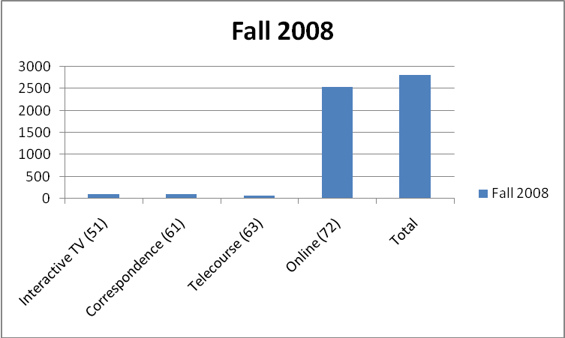

Characteristics of Individuals Served
Planning and Research Data Spring 2008
(For additional years, see Appendix B)

Spring 2008 | Less than 20 | 20-24 | 25-29 | 30-34 | 35-39 | 40-49 | 50-59 | 60+
ITV (51) | 37 | 78 | 37 | 14 | 11 | 8 | 2 | 0
Correspondence (61) | 18 | 43 | 47 | 37 | 38 | 37 | 6 | 5
Telecourse (63) | 78 | 110 | 97 | 25 | 30 | 54 | 14 | 7
Online (72) | 744 | 947 | 486 | 398 | 280 | 259 | 79 | 12

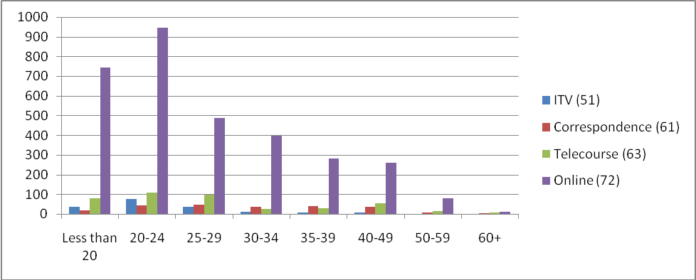

Spring 2008 | Male | Female | Others
ITV (51) | 46 | 141 | 0
Correspondence (61) | 93 | 138 | 0
Telecourse (63) | 76 | 339 | 0
Online (72) | 788 | 2410 | 7

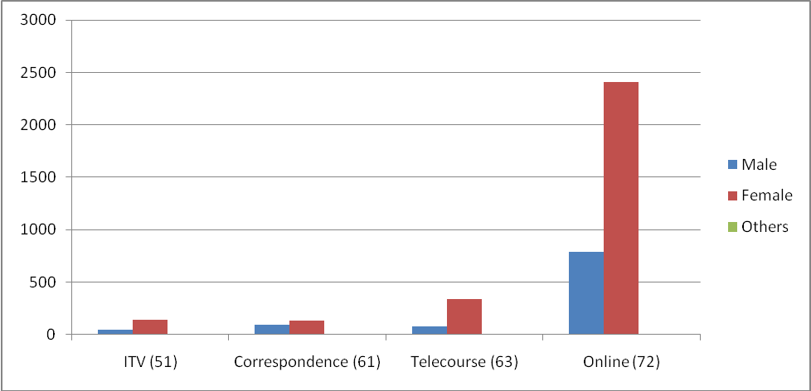

Spring 2008 | PELL | No Pell
ITV (51) | 32% | 68%
Correspondence (61) | 25% | 75%
Telecourse (63) | 38% | 62%
Online (72) | 32% | 68%

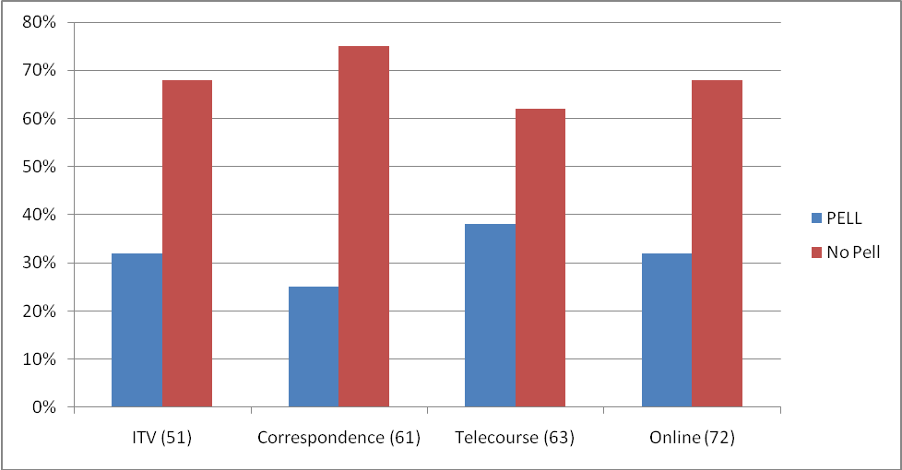

Spring 2008 | Am. Indian or Alas | Asian or Pacific Isl | Black Non-Hispani | Hispanic | White Non-Hispan | Others
ITV (51) | 5 | 8 | 8 | 74 | 73 | 19
Correspondence (61) | 4 | 8 | 34 | 94 | 74 | 17
Telecourse (63) | 0 | 24 | 32 | 170 | 181 | 8
Online (72) | 54 | 163 | 143 | 1299 | 1262 | 284

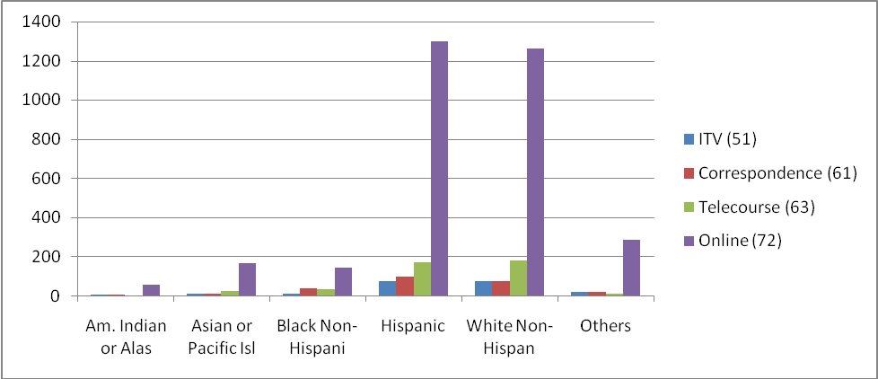

Spring 2008 | Local HS | Not Local HS | Unknown
ITV (51) | 104 | 81 | 2
Correspondence (61) | 75 | 145 | 11
Telecourse (63) | 186 | 223 | 6
Online (72) | 1480 | 1666 | 59

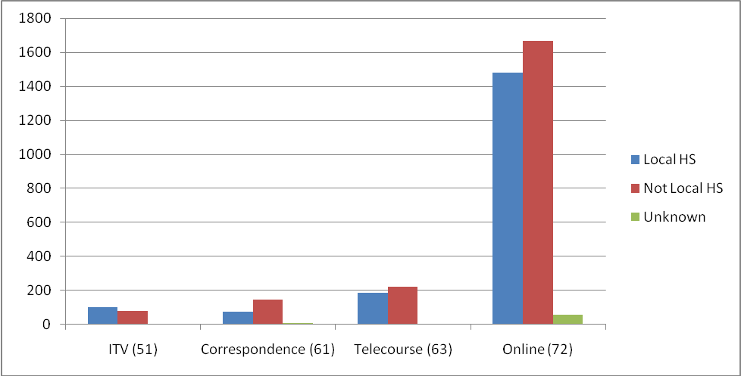

Distance Education Program Objectives

- Secure an institutional commitment for regular upgrade of the technology infrastructure.
- To grow the program so that it can meet the needs of the college service community.
- Identify distance education faculty mentors across each content division.
- Provide professional development to faculty interested in or already teaching through distance education modalities.
- Ensure all students, whether at a distance or on campus, have the same opportunity for access to all college services.
- Secure a Distance Education Division budget to facilitate coordination of the program, recruitment and training of faculty, hardware and software support, outreach efforts to recruit students and enable the division to grow.
- Work with the campus community in developing and implementing new distance education courses/programs, evaluation and assessment procedures for students and faculty. (From DE Plan Draft 1/07, approved by DECOS 10/28/08)

What major changes over the past several years, both external and internal to the college, have affected the program?

The State of California has seen a tremendous growth in distance education since 1995. In the 1995-96 academic year, the total student headcount in distance education was 54,524, growing to 301,073 in 2005-06 (California Community College Board of Governors, 2007, DE Report 5.5). Changes to Title 5 have enabled the expansion of online classes. Web-based technology has evolved to provide user-friendly course management systems and stand-alone communication tools. Textbook publishers have incorporated course management systems and media into easily accessed web-based tools for delivering courses.

Colleges are responsible for addressing distance education issues specifically in terms of Title 5 compliance, accreditation standards, Section 508 (accessibility) compliance, and attention to legal use of copyrighted digital media. Additionally, there are specific terms in the Higher Education Act 2008 that pertain to distance education.

There have been many changes affecting distance education at COS, specifically. Since the first classes were offered in 1998, there has been in increased interest among faculty, administration, and students. The College created and filled a full-time faculty position, Distance Education Coordinator (DEC) in Fall 2007. Many departments have submitted curriculum revisions to include a Distance Learning Addendum. The College has invested considerably in hardware and software to support Interactive TV classes. Faculty development opportunities include workshops focused on effecting teaching using technology. The College entered into a 12-month trial license with an experimental course management/academic networking system, Epsilen Environment.

Part II: Need for the Program
Why create a distance learning program at COS?

The COS district encompasses an immense geographic range and widely scattered communities. The people of Kings and Tulare counties are underserved in easy access to higher education compared to most of California’s population. Thus, distance education from COS is particularly critical to those living in such widely disparate areas as Giant Forest, Alpaugh and Sultana.
Currently across the state of California, enrollments are down. A strong distance education program can increase enrollments without a reciprocal growth in facilities. Additionally, there is a new population of prospective students that are not completely served. These students are those in state institutions and hospitals.
Finally, the home computer along with Internet access has become as commonplace as the television. The use of educational technology both in and outside of the classroom is expected by our service population. Most community college students have a multitude of responsibilities in additional to school. In order to best serve our students, we must be proactive in creating alternative methods for accessing education that fits into the busy lifestyle of the population we serve. (From DECOS DE Plan, January 2007)

Part III: Finances
Revenues

Revenues for DE are solely generated by FTES.

FTES | Online/Hybrid | Interactive TV | Telecourse | Correspondence
Fall 2006 | 11.66 | 9.87 | 40 | 13.7
Spring 2007 | 224.23 | 16.28 | 40.2 | 10.1
Fall 2007 | 247.47 | 7.6 | 33.6 | 31.87
Spring 2008 | 292.17 | 29.93 | 54.3 | 18.1
Fall 2008 | 468.07 | 36 | 27.6 | 9.8

Costs

DE program costs occur in the following areas: Faculty salaries, including DEC salary; annual Blackboard License fee($15,000 in 2008-2009); 10% Computer Services support person; supplies ($1,500 annual max). The ratio of FTES to FTEF are displayed in the following chart (x FTES: 1 FTEF)

FTES:FTEP | Online/Hybrid | Interactive TV | Telecourse | Correspondence
Fall 2006 | 1.58 | 12.87 | N/A | 11.42
Spring 2007 | 14.31 | 12.03 | 8.04 | 6.31
Fall 2007 | 11.33 | 14.25 | 14.0 | 13.66
Spring 2008 | 14.17 | 16.94 | 16.97 | 15.08
Fall 2008 | 13.67 | 22.04 | 11.5 | 13.37

Efficiencies and cost containment approaches

Distance education faculty use existing computer resources to teach distance education courses.
The College uses a basic version of Blackboard© (Bb) course management system for online courses. The basic version is purchased at an annual rate negotiated by the Chancellor’s Office. The cost for 2008-2009 was approximately $15,000.00. The Distance Education Coordinator (DEC) is responsible for basic management of Bb, relieving Computer Services from some workload, particularly at the beginning and end of each semester. The DEC coordinates with Computer Services for technical trouble-shooting and support.
Faculty use of publisher course management systems is growing. The implication is that faculty are using course management systems that are not managed or maintained by COS, freeing many costly resources.

External support

Distance education does not receive any external support except for grant funds made available through the State of California for providing video captioning. The amount of captioning funds available are approximately $12,000.00.

Part IV: Quality

Success/Non-Success

According to the California Community College Board of Governors in 2007, the success rate for students in distance education courses from 2001-2002 through 2005-2006 Success rate was 57%, compared to a success rate of 63% in traditional credit courses in 2001-2002, 64% in 2004-05, and 63% in 2005-06.

COS success rate during the fall 2007 term is displayed in the table below. Success is defined as passing the course with a grade of A, B, C, or Credit (CR).

Fall 2007 | Success | Not Success
ITV (51) | 48% | 52%
Correspondence (61) | 43% | 57%
Telecourse (63) | 47% | 53%
Online (72) | 52% | 48%

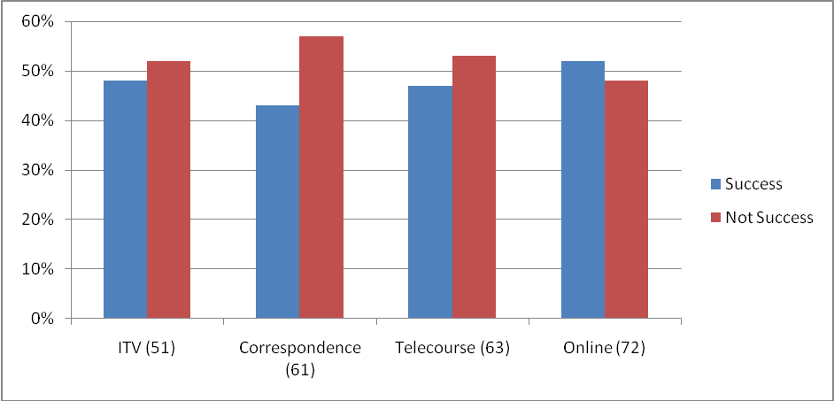

The low success rate may be attributed to students retained in the course (those who never drop) who simply stop participating or responding to faculty-initiated contact.

The fall 2007 retention rates are displayed in the table below. If a student has dropped the course, the student is not included in the retention data.

Fall 2007 | Retained | Not-Retained
ITV (51) | 82% | 18%
Correspondence (61) | 70% | 30%
Telecourse (63) | 72% | 28%
Online (72) | 89% | 21%

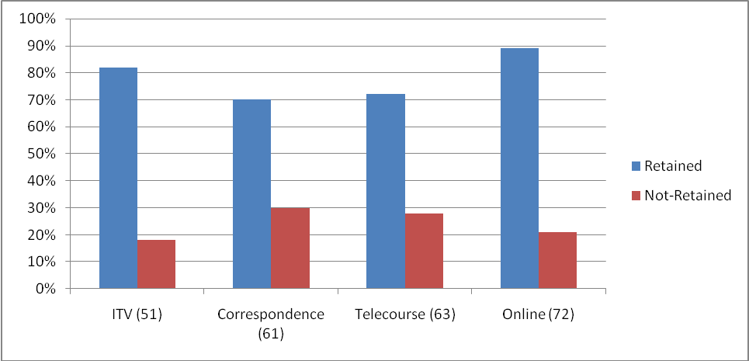

Satisfaction of Students

Student evaluation of specific online courses is accomplished through program review and faculty evaluation processes.

A distance education student satisfaction survey was distributed in the spring of 2008 (See Appendix C). The following is a summary of the survey final report (see Appendix C). 163 completed responses were received from Tuesday, April 15, 2008 to Monday, May 12, 2008.

42% of the students who responded to the survey were taking their first distance education course, 51.9% had taken two to five distance education courses. Over 60% of students indicated their goal was to receive a degree. Others indicated other goals, including transfer (nearly 30%) certificate (5%), personal interest (1.3%), and other (3.8%). Students’ employment status included the following: 22.8% were not employed, 1.9% work 1-5 hours per week, 1.9% work 6-10 hours per week, and 20.4% work 11-20 hours per week, 53.1% work more than 20 hours per week. 22.8% of respondents had completed 0-15 credits at COS, 18.5% had completed 16-30 credits, 28.4% 31-45 credits, and 30.2% had completed 46 or more credits at COS. Primary motivation for taking a distance education course included work or family commitments 55.6%, 8.1% distance from campus, 4.4% on-campus class was full, 6.9% no on-campus class available, 11.3% more comfortable in a distance education class, 13.8% other. Other responses included: good opportunity for interaction; fit into my school schedule better; work during the day; convenience; flexibility; disabled; preferred instructor; and save on gas. Most students (85.8%) used a home computer for their online course, 12.3% used campus computers, and 1.9% used a computer at their place of work. Students rate their computer expertise as novice (7.4%), intermediate (69.8%), or expert (22.8%). Students rate the time spent working on the course compared to an on-campus course as more work (27.8%), same amount of work (62.3%), less work (4.3%), or not applicable (5.6%). 63.6% of students indicated they would complete their degree or certificate online if they could.

Over 90% percent of respondents strongly agreed or agreed to the following items:
I achieved the learning outcomes
The course met my expectations
It was easy to use the technology
Course materials were easy to access
Course materials were interesting
Assignments were clearly related
The instructor responded to questions in a timely fashion
I would take another distance education class
I was satisfied with the course

Satisfaction of Faculty

A satisfaction survey was distributed to 40 full-time and part-time instructors teaching distance education courses in the spring of 2008. The survey was made available in Blackboard. Eight instructors completed the survey. A copy of the survey with results is available in Appendix D. What follows is a summary of the results:
- Instructors responding to the survey indicated that they had taught as many as 15 distance education courses, with the majority (62.5%) having taught 6-10 courses. 25% had taught 1-5 courses. 75% percent have taught online and 25% interactive television courses.
- Some instructors indicated that they had taken distance education certification courses or graduate-level courses via distance education to be able to see the experience from the student’s perspective. 50% of respondents have had college or university training to become a distance educator. 37% have taken @One training. 12.5% have had no training, and 25% indicate that they have had “other” type of training.
- Instructors rated themselves as somewhat knowledgeable (37.5%) about copyright law as it relates to online course materials, or knowledgeable (62.5%). None of the respondents rated themselves as very knowledgeable.
- Most respondents (62.5%) indicated that the experience of developing a distance education course has had a positive impact on their classroom teaching.
- Instructors are satisfied (75%) or very satisfied (25%) with the quality of student-faculty interaction in their classes. Instructors are somewhat satisfied (25%), satisfied (62.5%), or very satisfied (12.5%) with the quality of student-student interaction in the classes.
- Instructors are satisfied (75%) or very satisfied (25%) with teaching a distance education class during the spring semester.
- All respondents would consider teaching other distance education classes in the future.
- All the respondents who taught online classes accessed a computer from home most frequently.
- All respondents were satisfied with Blackboard.
- None of the respondents indicated that they would like to teach online exclusively.
- Instructors are not satisfied with students’ technical skills (12.5%), somewhat satisfied (37.5%), satisfied (25%), or very satisfied (25%).
- Instructors are somewhat satisfied (50%), satisfied (37.5%), or very satisfied (12.5%) with students’ computer access at school.
- Instructors are somewhat satisfied (12.5%), satisfied (75%), or very satisfied (12.5%) with students’ access to library services.
- Instructors are not satisfied (25%), somewhat satisfied (12.5%), satisfied (50%), or very satisfied (12.5%) with students’ access to counseling services.
- Instructors are not satisfied with COS technical support (12.5%), somewhat satisfied (12.5%), satisfied (62.5%), or very satisfied (12.5%).

Advisory committee members and activities

A distance education committee has been in existence at COS in some form or another since 1996. The current committee, Distance Education at COS (DECOS), is an Academic Senate committee comprising voting faculty members from math, science, English, social science, nursing, library, counseling, and business. Advisory members include staff and management representatives from Computer Services, instructional media, and the Learning Resource Center (LRC). DECOS meets on the second and fourth Tuesdays of the month from 2:10-4:00.

The Distance Education Coordinator is planning to create a community advisory group for distance education at COS. Nominees are being selected at the DECOS October 28th regular meeting. It is recommended that the group meet annually to discuss issues related to distance education.

Quality of Equipment and Facilities

Blackboard (Bb)
Bb is a course management system that enables instructors to post documents with text and graphic representations, PowerPoint slides, and images. Additionally, instructors use discussion boards to support student communication and learning. Instructors also link to resources on the World Wide Web through their Bb shells. Instructors use Bb to communicate with students through Announcements, email messages, and discussions. Instructors can develop and manage groups for collaborative work. Bb enables a paperless classroom through the above tools, as well as through the use of the Digital Dropbox which enables instructors and students to exchange documents.
Bb Student authentication processes include Banner registration and data transfer to Bb rosters. Students must log in to Bb with their student ID and password. Instructors utilize a variety of security features including multiple methods of assessment, timed tests, and password-protected tests.
Bb usage is at 324 active course shells with approximately two thirds of the shells being used for enhancing instruction of non-distance education classes. Over 130 different faculty members are using Bb to a greater or lesser extent.
The College has purchased a license for the Basic version of the Bb course management system since 1999 utilizing special pricing made available by an agreement between Bb and the California Community College Chancellor’s Office. In anticipation of the College adopting a new course management system for the 2009-2010 academic year, the VP for Instruction selected to purchase a one-year Bb license for 2008-2009 at approximately $15,000, rather than commit to a two-year commitment at approximately $12,000 per year.
Our Bb server is located on the COS campus and is maintained by Computer Services. Server space is limited, so instructors are advised to work with the Instructional Media department to locate media resources for courses. Since server space is limited, instructors are also advised not to use the Bb collaboration, or chat, tool for their courses. Instead, instructors are directed to CCCConfer to develop real-time collaboration sessions for class sessions or communication with students.
The Distance Education Coordinator (DEC) along with Computer Services department personnel manage the Bb system on campus. The DEC communicates with faculty to develop new course shells each semester and coordinates with Computer Services to facilitate data transfer from Banner to Bb to establish student access to Bb courses.
Faculty and student Bb technical support is provided M-F during working hours by the DEC and Computer Services. The DEC provides faculty with Bb training.

External Course Management Systems
A small number of instructors (estimate of less than 10) use external course management systems provided by publishers (e.g., MyMathLab, Course Compass, Eduspace, and Etudes). Students must purchase access keys, typically along with a required text, to be able to log in to these course management systems. COS has no administrative access to these external course management systems and provides no technical or management support to students or faculty for these systems. Generally, these external course management systems provide 24/7/365 technical support, themselves.

Computer access on campus
According to the Spring 2008 Student Satisfaction Survey, 12% used computers on campus.

Computer access at home
According to the Spring 2008 Student Satisfaction Survey, more than 85% of the students responding used a computer at home for their online courses.
Instructors report that students have difficulty with file management, application compatibility (MS Works, MS Word 98, 2004, 2007), and browser compatibility with our version (6.0) of Bb.

Interactive TV (ITV)
We have two ITV classrooms on the Visalia campus and one at Hanford. Quality issues include the T-1 line, microphone issues, faculty training, and poor image quality.

Smart classrooms
We have 64 smart classrooms with computers, document cameras, and projection systems. Instructors can display images from document cameras, show media and computer files, and go online and display web pages. In hybrid courses that meet face-to-face occasionally, instructors display course management system pages to support learning, as well.

Faculty Development

The Academic Senate of the California Community Colleges recommends that the institution provide the faculty with support services specifically related to teaching online: “Colleges that offer distance learning courses must plan, prepare, budget and implement ongoing faculty development and technical support in a timely, systematic manner” (Academic Senate CCC, 1999, p. 9).
In-house faculty development for distance education is developed and delivered by the Distance Education Coordinator (DEC). Additionally, faculty are encouraged to take advantage of Faculty Enrichment Committee (FEC) development offerings. The DEC works in collaboration with the FEC chair to develop and facilitate training for faculty in distance education pedagogy and technology integration.
The DEC disseminates information about distance education training opportunities available to faculty from State and national resources.
The DEC also actively provides curriculum resources to faculty through email messages, as well as through the DE@COS Bb “course.”

Technical Support
Computer Services
The Computer Services department is responsible for providing technical support to faculty and for maintaining faculty and student computers on campus. According to the Spring 2008 Student Satisfaction Survey, 12.3% of the students who responded to the survey use computers on campus for their distance education classes and over 85% use their home computers for distance education classes.

Instructional Media (IM)
The Instructional Media department supports faculty with media production (e.g., video, audio, PPT) and storage (e.g., IM server, iTunes University).
Distance Education Coordinator (DEC) provides technical support to faculty for Blackboard (Bb) management purposes (e.g., user management, Bb feature management). The DEC also provides support for MS applications when necessary.

Administrative Support

The Distance Education Coordinator receives occasional administrative assistant support from Annette Bishop, special assistant to the VP for Instruction. The support takes the form of creating and disseminating meeting summaries for the Distance Education at COS Committee (DECOS) along with occasional support for procurement of supplies.
A COS Administrative Assistant, Fay Moline, provides occasional support to instructors of correspondence classes in terms of routing mailings.

Innovative Activities or Services

COS is currently in a 12-month trial license with the Epsilen Environment. The Distance Education Committee (DECOS) is implementing the trial. The trial involves faculty members, some of whom are members of DECOS and some who were admitted to the trial through an application process. There are 10 active Epsilen courses as of October 2008.
The Epsilen Environment is a web-based tool enabling students to develop e-portfolios, participate in academic social networking, and engage in courses taught through a course management system. The 12-month trial is designed to provide DECOS with enough information to provide a recommendation to the College about whether or not Epsilen should replace Blackboard (Bb) as the college-supported course management system.

Course and Curriculum Development

Divisions continue to be responsible for development of programs and curriculum that meets the distance educational needs of students. The decision to offer courses at a distance will be done on the division level including the identification of appropriate modalities of delivery. The Distance Education Coordinator will be available for consultation to assist in these types of decisions.
Scheduling of distance education courses will be done collaboratively between divisions and take into consideration prior enrollments and student need. Divisions will also follow the processes and procedures that are currently in place at COS to choose appropriate faculty to teach distance education sections. (From DE Plan Draft 1/07)
All courses must be separately approved for distance education delivery. A Distance Learning Addendum (DLA) is completed and added to an approved course outline. The DEC makes a recommendation, and the Curriculum Committee approves the DLA.

Student Academic and Other Student Outcomes Assessment

COS has been participating in a Student Learning Outcomes (SLO) initiative since Spring 2004. Every department is developing SLOs in conjunction with SLO assessment plans. SLOs apply to distance education courses in the same way they apply to face-to-face classes.
The Curriculum Committee reviews all new and revised course outlines on a formal basis. All new and revised course outlines must include SLOs and assessment plans.
The program review process within divisions includes attention to SLOs.
The COS Distance Education Committee (DECOS) has developed SLOs for distance education (approved by DECOS, April 2008):
1. Students will use appropriate information and tools in determining their own readiness to take an online course.
2. Students will demonstrate increased knowledge of distance learning strategies.
3. Students will demonstrate appropriate technology skills.
4. Students will achieve learning objectives for distance education classes.

Student Support

Students have reasonable and adequate access to the range of student services and student rights appropriate to support their learning. Student Services offices, such as financial aid, admissions and records, and counseling are available to students online. The Learning Resource Center (LRC) also provides online access to students for catalog searching, access to online full-text articles and e-books, access to librarians through the Ask a Librarian service.
The Distance Education Coordinator (DEC) has recently developed and launched a collection of web pages linked from the COS home page. These pages include the following: Link to Blackboard (Bb); instructions for logging in to Bb; distance education frequently asked questions (FAQ); faculty contact list; distance education program definition and contact information; a student readiness survey; a student orientation to distance education and technology at COS; and links to student services.

Student Readiness
The method in place to assess the extent to which a student has the background, knowledge and technical skills required to undertake distance education includes an online orientation to distance education at COS and an online survey of distance education learning readiness (Is Online Learning for Me?). A Technical readiness survey is being developed. These surveys will be available on the COS web site distance education pages.
Instructors are encouraged to direct students to readiness tools and activities as they begin their classes each semester.

Student Authentication
Current student authentication procedures include Banner registration and data transfer to Bb. Students must use current student identification and passwords to access course management systems (e.g., Bb, Course Compass, Eduspace). Additional student authentication procedures are managed by instructors in individual classes. Such class practices include multiple methods of assessment, timed online tests, password-protected tests, among others.

Linkages with External Organizations

The California Community College Chancellor’s Office has developed an email listserv for the Distance Education Coordinators at the California community colleges (DECOORD). The Chancellor’s Office also provides technical support for the DEC, including training modules, reports and surveys, and consultation.

External grants or other awards
Funds are available for video captioning through a grant from the State of California.

Compliance

Ed Code,
References within the California Education Code include the basic establishment of distance learning policy, primary goal for the use of educational technology, and standards for course and program quality:
Section 66940: There is hereby established the California Distance Learning Policy, which sets forth the guiding goal and principles for the utilization of technology in California postsecondary education.
Section 66941 a.: …Access to a high quality education is the primary goal for the use of educational technology in higher education.
Section 66941 c.3 Assurance that the standards for course and program quality applied to distance education are rigorous in meeting accreditation standards, Universal Design Standards, and standards currently applied to traditional classroom instruction at higher educational institutions in the areas of course content, student achievement levels, and coherence of the curriculum.

Title 5
In 2008, the California Community College Chancellor’s Office distributed new Distance Education Guidelines, pertaining to California Code of Regulations, Title 5 rules which apply to the design, approval, conduct, and reporting of distance education within California community colleges. The Board of Governors for the California Community Colleges approved the related documents at various dates, hence the omnibus designation for the document;
The following is a summary of the guidelines for Sections 55200 Definition and Application; 55202 Course Quality Standards; 55204 Instructor Contact; 55206 Separate Course Approval; 55208 Faculty Selection and Workload.

Title 5 §55200
Definition and Application
- Distance education means instruction in which the instructor and student are separated by distance and interact through the assistance of communication technology.
- …instruction provided as distance education is subject to the requirements that may be imposed by the Americans with disabilities Act and section 508 of the Rehabilitation act of 1973.
Guidelines for Title 5 §55200

- Faculty need to receive appropriate training in order to ensure that they understand what constitutes accessibility
- Institutions must provide faculty with both the necessary training and resources to ensure accessibility.
- “All college administrators, faculty and staff who are involved in the use of this instructional mode share this obligation” (p. 5).
- Accessibility for persons with disabilities must be provided in the development, procurement, maintenance, or use of electronic or information technology by a community college district using any source of state funds
Basic Accessibility Principles

- Access must be “anytime, anywhere” without the need for outside assistance unless as “last resort” (e.g., sign language interpreters, aides, etc.)
- Provide “built-in” accommodations (e.g., captioning, descriptive narration)
- Provide printed information in appropriate alternative formats
- Access to DE courses, resources, and materials include audio, video, and text components of courses delivered via existing and emerging technologies
- If access to Web sites not controlled by the college is required, the college must take steps to ensure that such sites are accessible or provide the same material by other accessible means
- The level of communication should be the same for students with or without disabilities
- Third-party materials must be accessible
Title 5 §55202
Course Quality Standards

- The same standards of course quality shall be applied to any portion of a course conducted through distance education as are applied to traditional classroom courses.
- Determinations and judgments about the quality of distance education under the course quality standards shall be made with the full involvement of faculty.
Guidelines for Title 5 §55202

- Course quality depends upon the full involvement of faculty in the design and application of DE courses
- Normal course quality standards apply to any portion of a course conducted through distance education.
Title 5 §55204
Instructor Contact District governing boards shall ensure that:
  - Any portion of a course conducted through distance education includes regular effective contact between instructor and students, through group or individual meetings, orientation and review sessions, supplemental seminar or study sessions, field trips, library workshops, telephone contact, correspondence, voice mail, e-mail, or other activities.
Guidelines for Title 5 §55204

- It is the responsibility of the instructor in a DE course to initiate regular contact with enrolled students to verify their participation and performance status.
- The use of the term “regular effective contact” in this context suggests that students should have frequent opportunities to ask questions and receive answers from the instructor of record.
- For DE courses, there are a number of acceptable interactions between instructor and student, not all of which may require in-person contact. Colleges need to define “effective contact” including how often, and in what manner instructor-student interaction is achieved.
  - It is important to document regular effective contact and how it is achieved.
  - Regular effective contact is an academic and professional matter, thus documentation must include demonstration of collegial consultation with the Academic Senate, for example through its delegation to the local curriculum committee. A natural place for this to occur is during the separate approval process, as well as during faculty evaluations, student surveys, and program review.
  - Documentation should consist of the inclusion of information in applicable outlines of record on the type and frequency of interaction appropriate to each DE course/section or session.
  - Local policies should establish and monitor minimum standards of regular effective contact.
Title 5 §55206
Separate Course Approval

- If any portion of the instruction in a proposed or existing course or course section is designed to be provided through distance education in lieu of face-to-face interaction between instructor and student, the course shall be separately reviewed and approved according to the district’s adopted course approval procedures.
Guideline for Title 5 §55206
- Separate approval of a DE course is required if any portion of the instruction in a course or course section is designed to be regularly provided through distance education in lieu of face-to-face interaction.
Title 5 §55208
Faculty Selection and Workload

- Instructors of course sections delivered via distance education technology shall be selected by the same procedures used to determine all instructional assignments. Instructors shall possess the minimum qualifications for the discipline into which the course’s subject matter most appropriately falls.
- The number of students assigned to any one course section offered by distance education shall be determined by and be consistent with other district procedures related to faculty assignment.
- Nothing in this section shall be construed to impinge upon or detract from any negotiations or negotiated agreements between excusive representatives and district governing boards.
Guideline for Title 5 §55208

- Faculty delivering DE courses should meet the same minimum qualifications and be selected in the same manner as faculty teaching non-DE courses.
The guidelines address additional sections, including 55210 – MIS reporting; annual report to Board of Trustees (DN reported in January 2008); 58003.1 FTES Computation; 58006 Application of Actual Student Contact Hours of Attendance; 58007 Noncredit courses; 58009 Application of Alternate Attendance Procedure for Independent Study, Work-Experience and Certain distance Education Courses; 58051 Method for Computing FTES; 58056 Immediate Supervision and Control; 58170 Apportionment for Tutoring; and 59402 Instructional and Other Materials

Section 508
According to the IT Accessibility & Workforce Division (ITAW) Office of Governmentwide Policy Section 508 refers to accessibility of electronic and information technology:
In 1998, Congress amended the Rehabilitation Act to require Federal agencies to make their electronic and information technology accessible to people with disabilities. Inaccessible technology interferes with an individual's ability to obtain and use information quickly and easily. Section 508 was enacted to eliminate barriers in information technology, to make available new opportunities for people with disabilities, and to encourage development of technologies that will help achieve these goals. The law applies to all Federal agencies when they develop, procure, maintain, or use electronic and information technology. Under Section 508 (29 U.S.C. ‘ 794d), agencies must give disabled employees and members of the public access to information that is comparable to the access available to others. (Downloaded October 27, 2008 from http://www.section508.gov/index.cfm?FuseAction=Content&ID=3.
Title 5 DE Guidelines (see above) address compliance with Section 508.

WASC accreditation
In its publication, Distance Learning Manual August 2007, the Accrediting Commission for Community and Junior Colleges Western Association of Schools and Colleges sets distance learning policy:
ACCJC policy specifies that all learning opportunities provided by our accredited institutions have the same quality, accountability, and focus on student outcomes, whether they are delivered electronically or by more traditional means. The intent of the policy is to provide a framework that allows institutions the flexibility to adapt their delivery modes to the emerging needs of students and society while maintaining quality. Any institution offering courses and programs electronically is expected to meet the requirements of accreditation in each of its courses and programs and at each of its sites (p. 9).
Policy elements include the following:
- Development, implementation, and evaluation of all courses and programs, including those offered electronically, must take place within the institution’s total educational mission.
- Institutions are expected to control development, implementation, and evaluation of all courses and programs offered in their names, including those offered electronically.
- Institutions are expected to have clearly defined and appropriate student learning outcomes for all courses and programs, including those delivered through electronic means.
- Institutions are expected to provide the resources and structure needed to accomplish these outcomes.
- Institutions are expected to demonstrate that their students achieve these outcomes through application of rigorous assessment.
- Institutions are expected to provide the ACCJC reasons to believe that these outcomes will continue to be accomplished.
- Institutions are expected to give the ACCJC advance notice of intent to initiate a new delivery mode, such as electronically-delivered courses, through the Substantive Change process.
- Institutions are expected to give the ACCJC advance notice of intent to offer a program in which 50% or more of the courses are electronically-delivered, through the Substantive Change process.

What follows are notes related to WASC Distance Learning Manual Guidelines for Implementation:
Curriculum and Instruction
- Each electronically-delivered course or program of study results in learning outcomes appropriate to the rigor and breadth of the course credit, degree, or certificate awarded.
  - This is assessed at the department level.
- A degree or certificate program delivered partially or entirely through electronic means is coherent and complete and results in learning outcomes comparable to those delivered through other means.
  - This is assessed at the department level.
- Student experiences result in achievement of intended learning outcomes whether electronically-delivered courses provide for synchronous or asynchronous interaction between faculty and students and among students.
  - This is assessed at the department level.
- Portions of courses delivered through electronic means adhere to the same principles of academic quality and integrity as courses delivered entirely through these means.
  - This is assessed at the department level.
- The institution has an effective means of ensuring the integrity of the educational process in electronically delivered courses including assuring that the work submitted for credit by students is submitted by students actually enrolled in the course.
  - Student authentication is accomplished through College application and registration means. Additionally, if an instructor uses a web-based course management system, students enroll using student ID and password.

Institutional Context and Commitment
Role and Mission
- Delivery of courses and programs through electronic means is consistent with the institution’s role and mission.
  - See above re how DE mission supports COS mission.
- Review and approval processes ensure the appropriateness of electronic delivery to meeting the course and program objectives.
  - This is assessed at the department level.
- Specific needs of students for whom electronically delivered courses are intended are identified and addressed.
  - This is assessed at the department level. Additionally, the College makes learning and technical skills readiness instruments available to students on the COS website. The DEC is in the process of developing a course for students to help address learning and technical skills needs.
Learning Resources
- Appropriate learning resources are available to students who take electronically delivered courses.
  - This is addressed at the individual course level and the department level. Additionally, the LRC has developed and is continuing to develop online access to LRC services.
Students and Student Services
- Students receive clear, complete, and timely information on the curriculum, course and degree requirements, nature of faculty/student interaction, assumptions about technological competence and skills, technical equipment requirements, availability of academic support services and financial aid resources, and costs and payment policies.
  - Students have access to this information in multiple locations, including the COS web site and COS catalog. The new distance education web pages, linked from the COS home page, contains much of this information and development continues.
- Enrolled students have reasonable and adequate access to the range of student services appropriate to support their learning and assess their progress.
  - Student services is continuing to develop online access for their services. There are links from the de pages directly to student services web locations.
- Students have the background, knowledge, and the technical skills needed to successfully use the technology involved in their course work.
  - The College makes learning and technical skills readiness instruments available to students on the COS website. The DEC is in the process of developing a course for students to help address learning and technical skills needs.
- Advertising, recruiting, and admissions materials clearly and accurately represent the courses and programs, and the services available.
  - Information about DE courses is provided in footnotes in the online and printed schedules.
Commitment to Support
- The institution demonstrates a commitment to ongoing program support, both financial and technical, and to continuation of the program for a period sufficient to enable students to complete a degree/certificate.
- The institution ensures that qualified faculty provide appropriate oversight of courses delivered electronically.
  - This is determined at the department level.
- The institution gives appropriate consideration to the technical skills and needs of faculty assigned to teach through electronic means.
  - The College created a new faculty position, Distance Education Coordinator, to provide faculty with technical and pedagogical training.
- The faculty evaluation process provides a means to evaluate technical skills when appropriate.
  - This is addressed at the individual faculty level per contract.
- The institution provides faculty training and support services specifically related to teaching via electronic means.
  - The College created a new faculty position, Distance Education Coordinator, to provide faculty with technical and pedagogical training.
Evaluation and Assessment
- The institution evaluates the educational effectiveness of electronically delivered course work, including assessments of student learning outcomes, student retention, and student and faculty satisfaction. Students have access to such evaluation data.
  - Effectiveness of coursework and SLOs are determined at the department level. The Distance Education Coordinator (DEC) requests data from IR concerning student success in order to determine faculty development needs. The DEC develops and conducts student and faculty satisfaction surveys annually. See discussion above.
- The institution provides for assessment of student achievement in each course and at completion of a program.
  - This is determined at the department level.

Part V: Learning and Recommendations

What have faculty and staff learned through the program review process?

Strengths

Distance education fits closely within the COS mission and student satisfaction is good. Faculty satisfaction and interest in DE are high and course offerings are increasing. The college established and filled the Distance Education Coordinator position, and DECOS is actively addressing policy and program needs. SLOs and other assessment is being designed and implemented at department level. Faculty continue to modify curriculum to include Distance Learning Addendums for existing and new courses.
Distance education courses are offered with a variety of teaching philosophies and methods, technology, curricula, and outcomes. Coordination of support for distance education faculty is informal and faculty driven enabling the further development of the wide variety of educational opportunities provided by the college.

Challenges

It is likely that distance education will continue to grow at COS, particularly our online offerings. We need to encourage additional faculty development in distance education pedagogy and curriculum development. It is essential to educate the faculty concerning Title 5 and Section 508 compliance issues related to distance education, as well as accreditation requirements. We also need to develop accessibility, copyright compliance, and usability assessment tools and implement a distance education accessibility check process. We also need to develop information and learning resources for students to increase student academic and technical skills.

What is planned as a result of what was learned – recommendations to improve or sustain quality and to address weaknesses?
DECOS will analyze the new DE Guidelines and make policy recommendations to the college and prepare and recommend accessibility and copyright compliance policies and procedures.
The DEC will prepare a preliminary Accreditation Report, prepare student learning resources for academic and technological skills, continue to develop faculty workshops for distance pedagogy and curriculum development, and develop information resources to encourage faculty communication with students to increase success rates.

